EXPERIMENT- 7

Aim: To draw the behavioral view (Collaboration) diagram for College Lost and Found System

Prerequisite:
- Basic understanding of functionality for the system to be designed
Outcome: After successful completion of this experiment students will be able to
- Understand the various model used for identifying behavior of a system to be designed.
- Compare and contrast the various behavioral models.

Theory:
What is Behavioral modeling?
All behavioral models really do is describe the control structure of a system. This can be things like:
- Sequence of operations
- Object states
- and Object interactions
Furthermore, this modelling layer can also be called Dynamic Modelling. The activity of creating a behavioural model is commonly known as behavioural modelling. As well as this, a system should also only have one behavioural model – much like functional modelling.
Two types of behavioral model are:
  - Data processing models that show how data is processed as it moves through the system;
  - State machine models that show the systems response to events.
  - These models show different perspectives so both of them are required to describe the system’s behavior.

How to draw Collaboration diagram?
Collaboration diagram is used to model how objects involved in a scenario interact, with each object instantiating a particular class in the system. Objects are connected by links, each link

representing an instance of an association between the respective classes involved. The link shows messages sent between the objects, and the type of message passed (synchronous, asynchronous, simple, balking, and timeout).
Collaboration diagrams offer a better view of a scenario than a Sequence diagram when the modeler is trying to understand all of the effects on a given object and are therefore good for procedural design.

Objects
Objects are depicted on a Collaboration diagram as rectangles. The object name is provided first, with the class name to the right; the two names are separated by a colon. You may specify the multiple occurrence of an object by opening its definition dialog, selecting its Symbol tab, and toggling on the Multiple choice. You may also select the Multiple Object tool from the toolbar.

Links
Messages passed between objects are specified within the Link drawn between objects.

Procedure:
- Identify various elements needed for a collaboration diagram
- Identify the behavior of the systems element with the external interfaces.
- Draw the collaboration diagram as per the guidelines.

Output: A Collaboration diagram for the system.

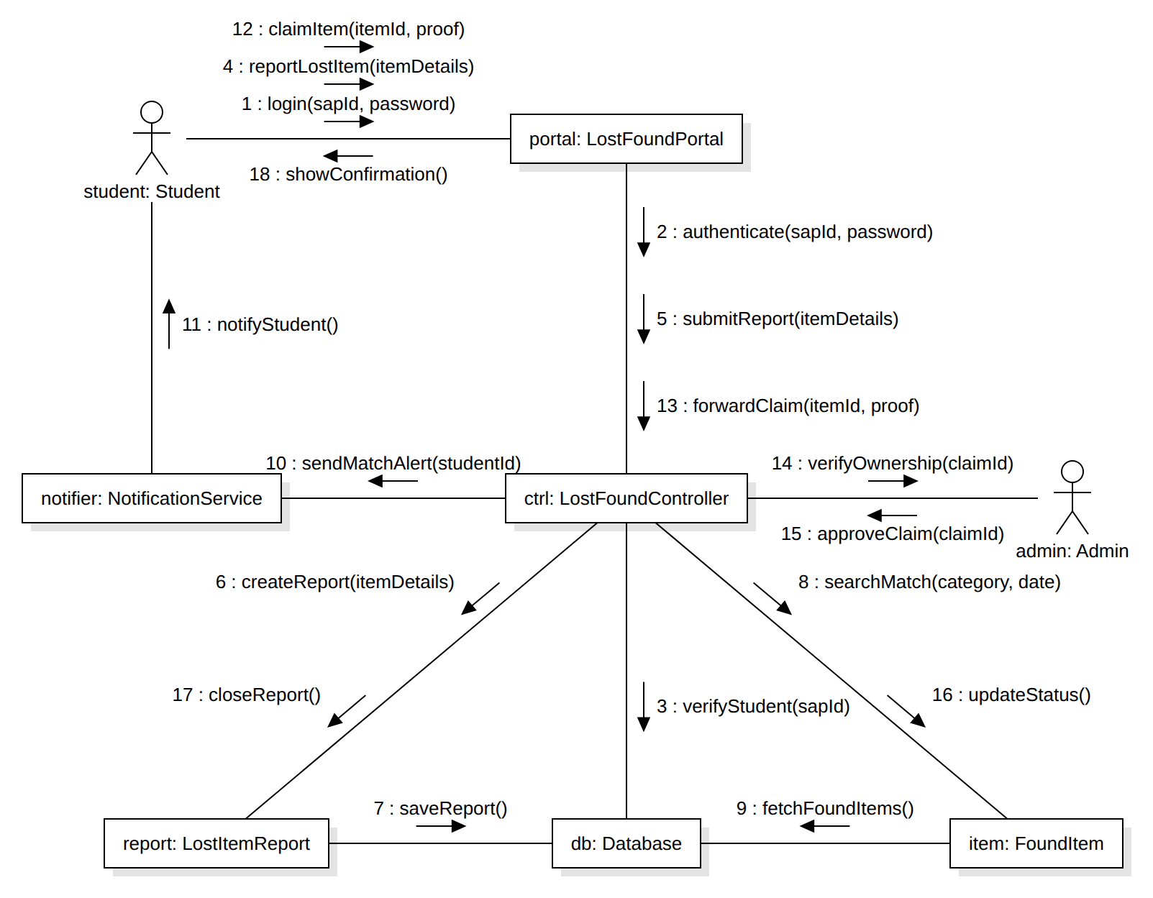
Fig 7.1: Collaboration diagram for College Lost and Found System

Conclusion: Thus, the collaboration diagram for the College Lost and Found System was successfully drawn using StarUML. The diagram shows how the Student, Admin and the system objects (portal, controller, lost item report, found item, database and notification service) are linked and interact through numbered messages to report a lost item, match it with found items, verify the claim and return the item to its owner.

